**Project work**

**Case Study:**

We get a internal requirment to create a Product manamgement application using following techonologies stack:

**Technology Stack: Spring Boot, Angular, Docker**

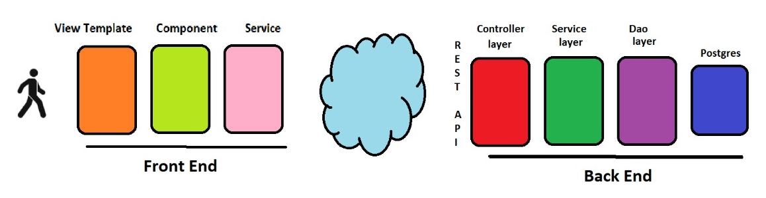

**Features Implementation**

* Create an Product
* List Products
* Delete Product
* Update Product
* Get Product by id

**Instructions**

* Project can to be done in team of 4 developers
* Team need to follow MVC design pattern and create seprate layer for persistance, service and controller in both front and backend. Need to implement common design patterns while implement project work
* Team need to create front end using Angular
* Use Docker to deployee application
* Deploy spring boot application to local Kubernetes cluster